**Assignment -04 (Array)**

1. Write a program in C to read n number of values in an array and display it in reverse order.
2. **Write a program in C to merge any two arrays entered by user at run-time**.

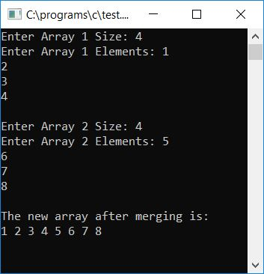

1. Write a Program in C that asks from user to enter any 10 array elements, and then ask to enter a number to search from the given array and print its position.

